**Introduction**

According to Wikipedia, London is the largest City in the UK and has been a major settlement for two millennia now. London is also considered one of the world's most important global cities in the world with attributes such as most visited, most infleuntial, most expensive and most vegetarian freindly city in the world. There is a saying in my culture which goes like this " L'homme c'est le ventre et le bas ventre". This just means a man cannot do without food and african food is known to be one of the best in the world. I can only recommend having a taste if you have never done by now

**Business Problem**

I have a friend living in Manchester who came some two months back to pay me a visit. He is into Food Business and is looking to open up a Sub-Saharan-African Restaurant in London neighborhood. Since he knows i am a data scientist, he asked to know which neighborhood will be the best suited for his Restaurant. The idea of this project is to locate the best Neighborhood in London to open a Restaurant for people of Sub-Saharan African descend. I will use the immigration data in London and Foursquare to evaluate and select the neighborhood suitable for my friend. This information could be of great help to Business people who may want to modify their Menu based on the preferences of the people living in that particular area.

**Data Set**

The data that would be used for this project is the immigration data taken from the London data store. This data presents Annual population survey based on diversity or country of birth. This data is published by the office for national statistics (ONS). The data set gives us information on the annual population survey of migrants, immigrants, british, UK born between 2004 and 2017. The population figures are measured in thousands. The other source of data was the venues in each Neighborhood in London collected from <https://developer.foursquare.com/>

**Variable Description**

* Year tells us the year in which the survey was conducted
* Area_Code is the code of the area in which the survey was conducted
* Area_Name is the name of the area in question
* Broad_goup tells us if the people surveyed are British, from the European Union or Non-European Union
* Detailed_group specifies where the people surveyed exactly came from. e.g from north america or south asia
* Estimate provides the estimated total number of people surveyed in thousands

A snapshot of the pre-processed data can be seen below

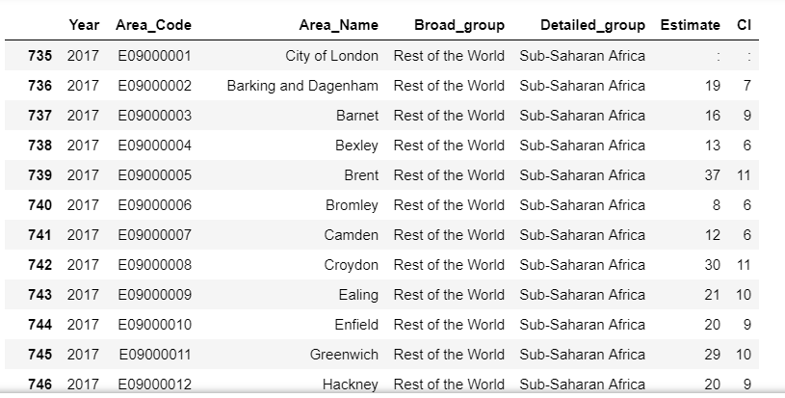

**Methodology**

I first started by looking at the development of Sub-Saharan African population between 2004 and 2017. That is to see which cities have welcomed my targeted group the most in the last couple of years. I found out that Croydon and Ealing have recieved the most Sub-Saharan africans in the last years as can be seen in the time series plot below

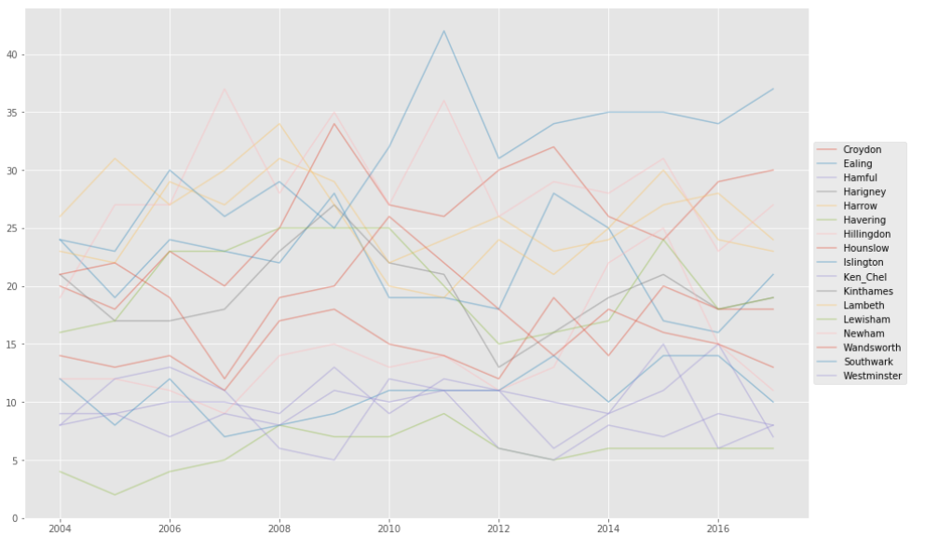

Furthermore, I looked at the map of London with its neighborhoods on the map.

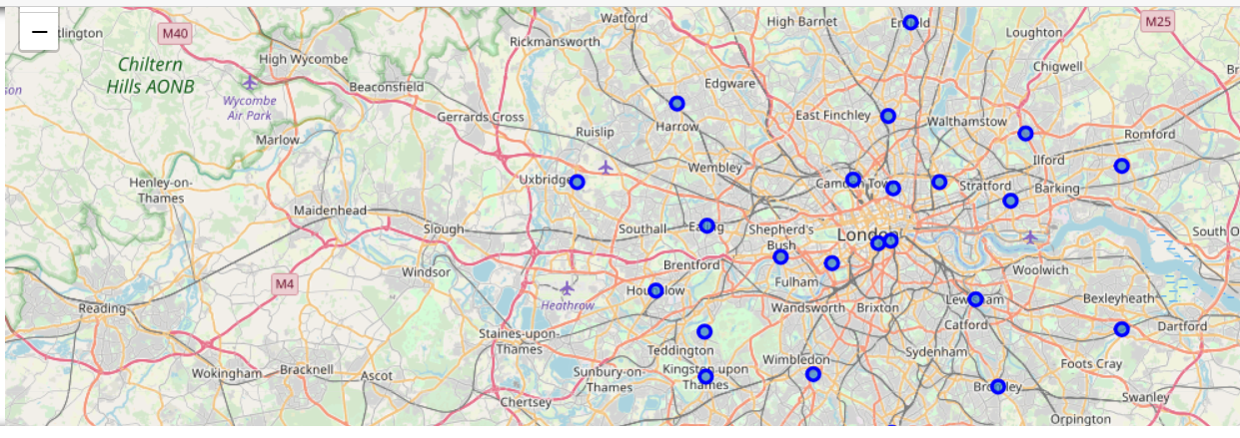

I then used the Euclidean Clustering method to cluster the african restaurants found in the London neighborhoods. In other to get quite a good number of Restaurants i chose a radius of 70000 and a Limit of 600.

**Results**

Using foursquare, i found out that there were about 76 african Restaurants within the chosen radius. I had a look at the frequency of african Restaurants in each neighborhood to have a feeling of where the majority of african restaurants are found at the moment.

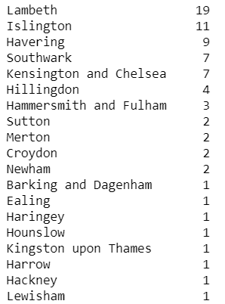

As the results above show, we have about 19 african Restaurants in Lambeth followed by Islington with 11. From the Time series plot above it could be seen that most people with sub-saharan descend have been moving to Croydon and Ealing but we only have two african Restaurants in Croydon and one in Ealing as can be seen from the frequency table above. This restaurants were also visualized on the map

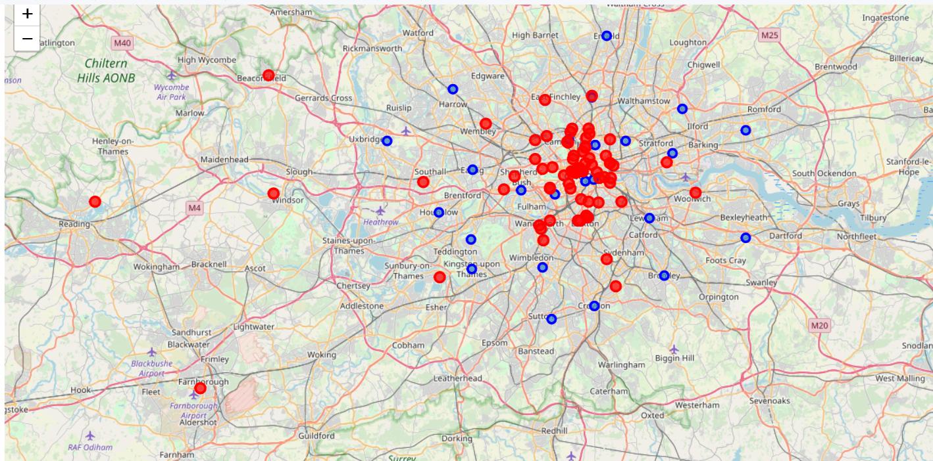

The identified restaurants were clustered and it can be seen that weh ad 6 clusters at the end.

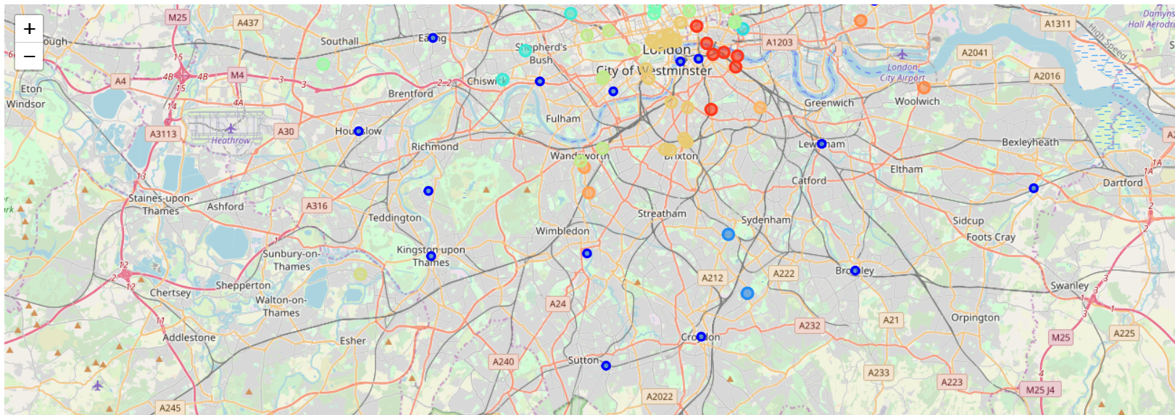

**Discussion**

* I noticed that using the foursquare data, one can get different results with the Geocode especially when you rerun the notebook
* One could think of using another Clustering Method instead oft he euclidean distance to compare results but from the method i used, i would recommend My friend to open the African Restaurant either in Croydon or Ealing

**Conclusion**

This project helped me to put some hands on into what we practiced about using foursqaure data to really draw maps and explore neighborhoods

Thanks for following me up in my analysis

Sammy N.